Website suggestions from Jun

1. The front page-we got a USA flag there, but there is no option to change it to Canada.

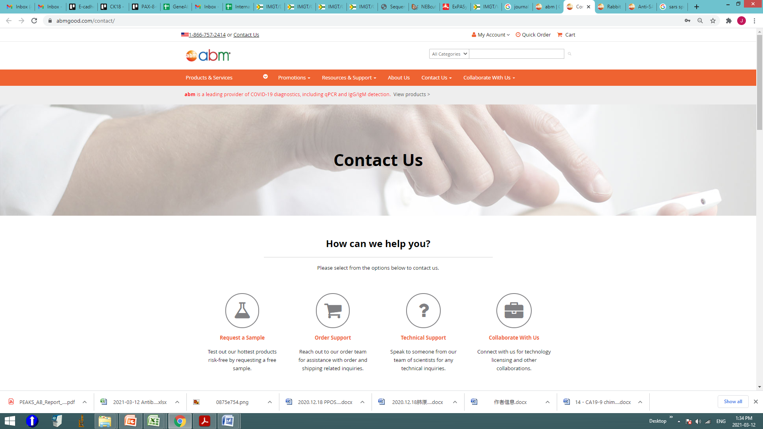

2. The searching function does not work for customer who are not too familiar with abm products. For example, a customer need goat anti mouse IgG secondary antibody. If they put “goat anti mouse IgG” in then there is nothing found.

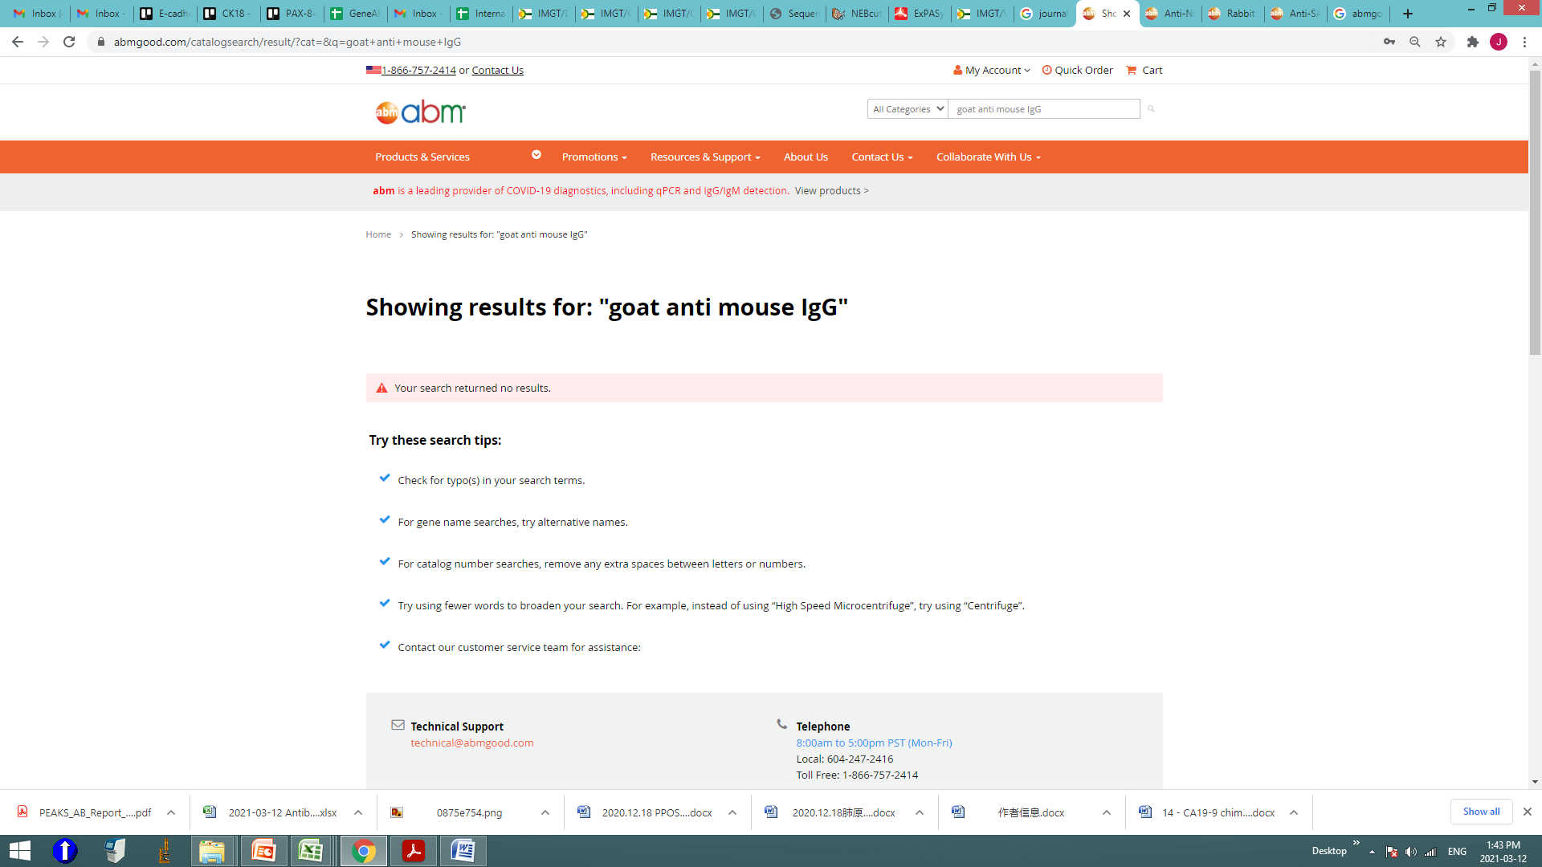

But we do have this kind of product like SG003. This product can only be found if I know there is such a product and exact product name or cat#. We can not find it following the secondary antibody products path and select the reactivity species and raised species, either…

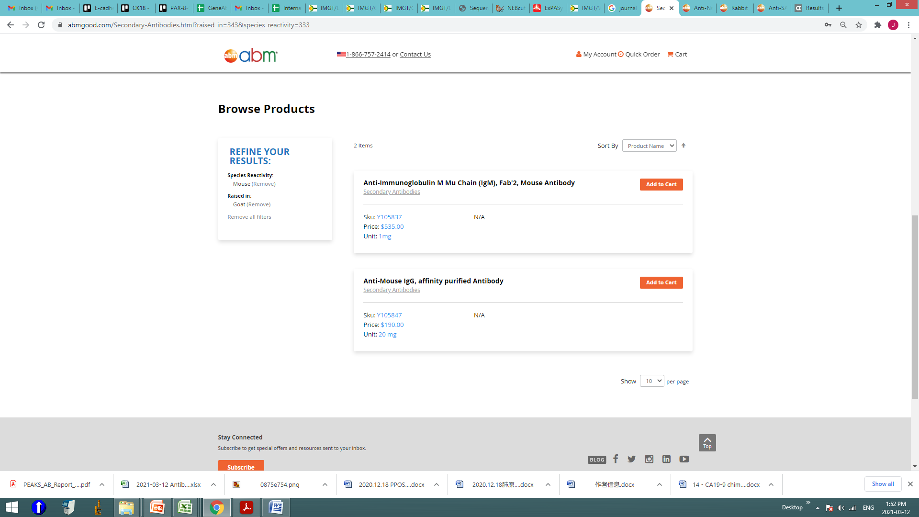

The searching function need to be easier and more efficient for our customer.

Similar request if we do with abcam website no matter we use as goat anti mouse IgG, or goat anti mouse secondary, or sth with similar meaning, it will direct to the right place.

3. In the searching result page, once we select or unselect any filter, the page returned to the top area with text introduction part, the real products can not be seen unless we scroll way down there, give a feeling that we left the page already.

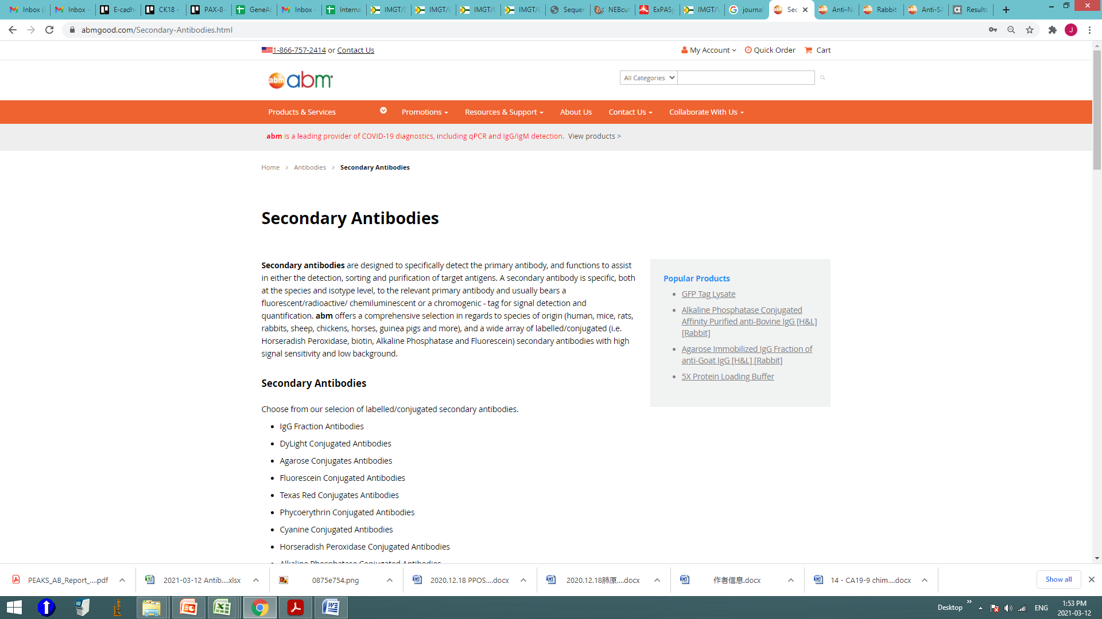

4. The searching really needs accurate keyword with our website. For example I want to find some anti-sars-cov2 antibodies there so I tested the searching for that. The website returned 18 result if I used “anti sars-cov2”, but found nothing if I say “sars-cov2 antibody” or “anti sars-cov2 antibody”

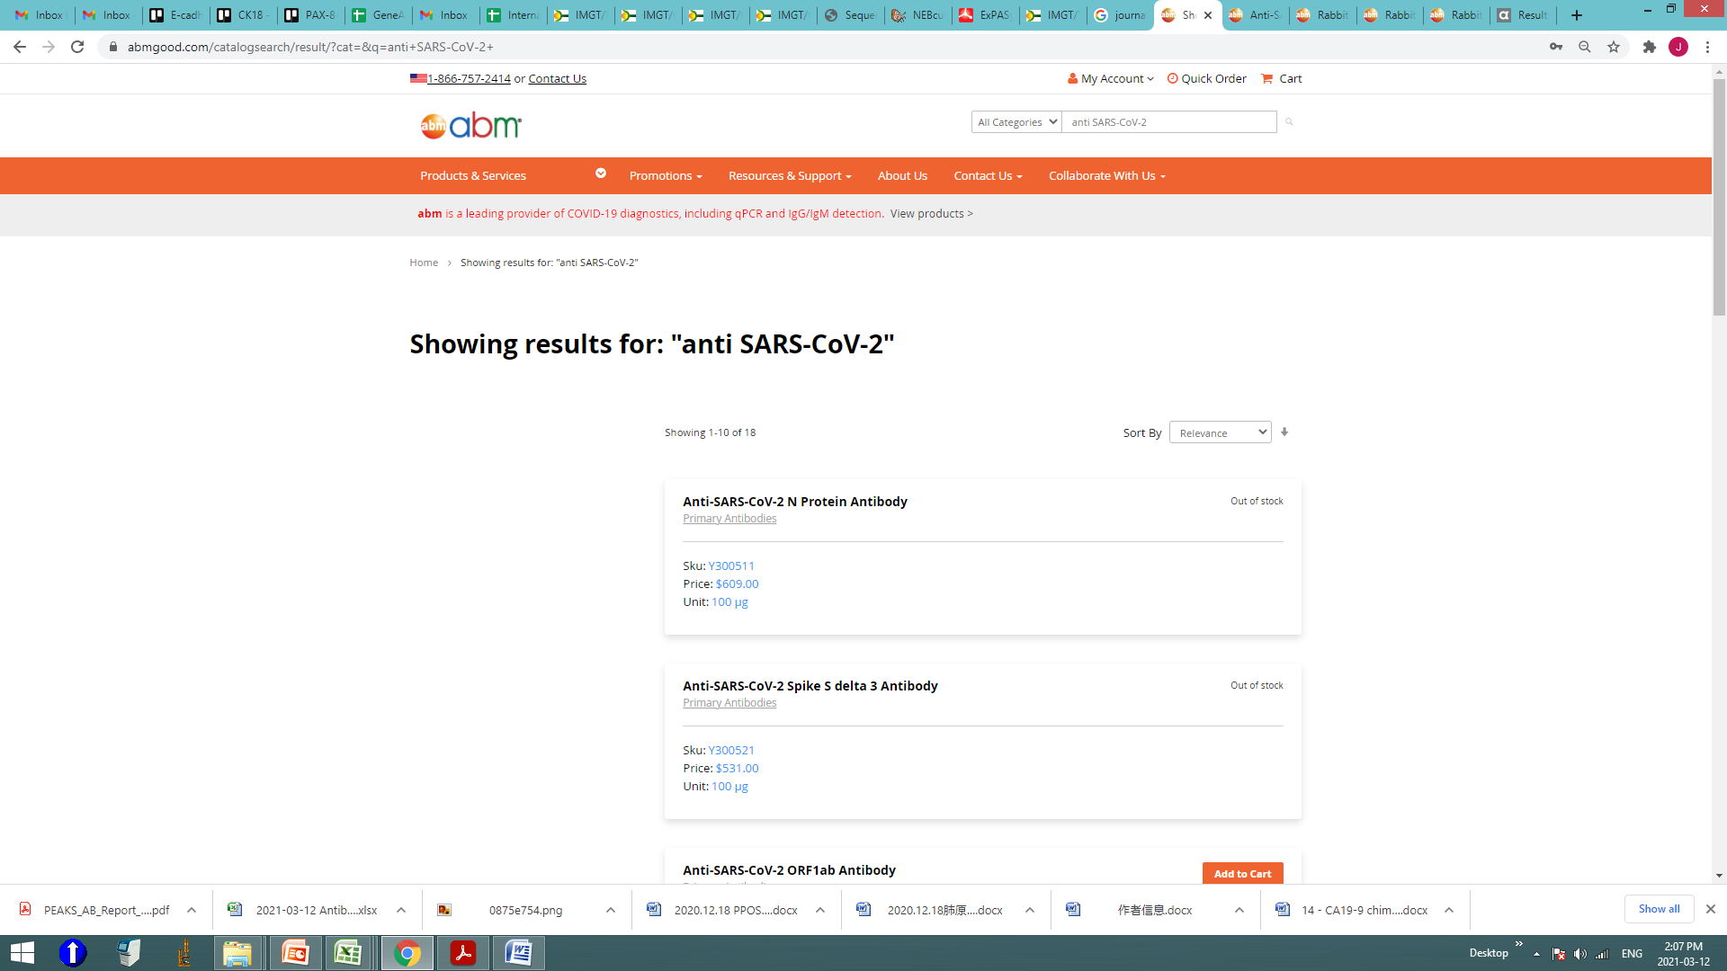

Here returned the searching result, but better have the filter function

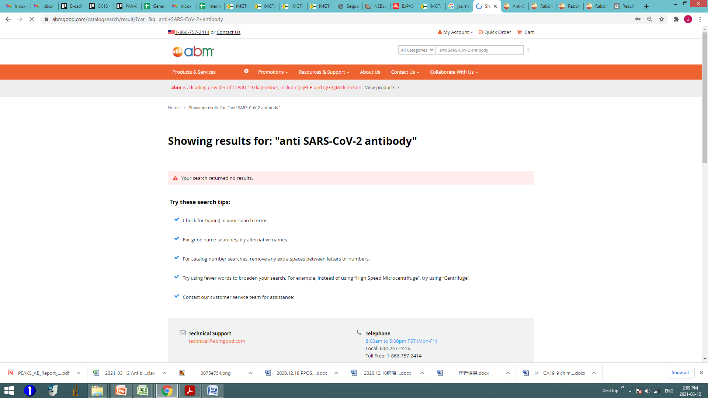

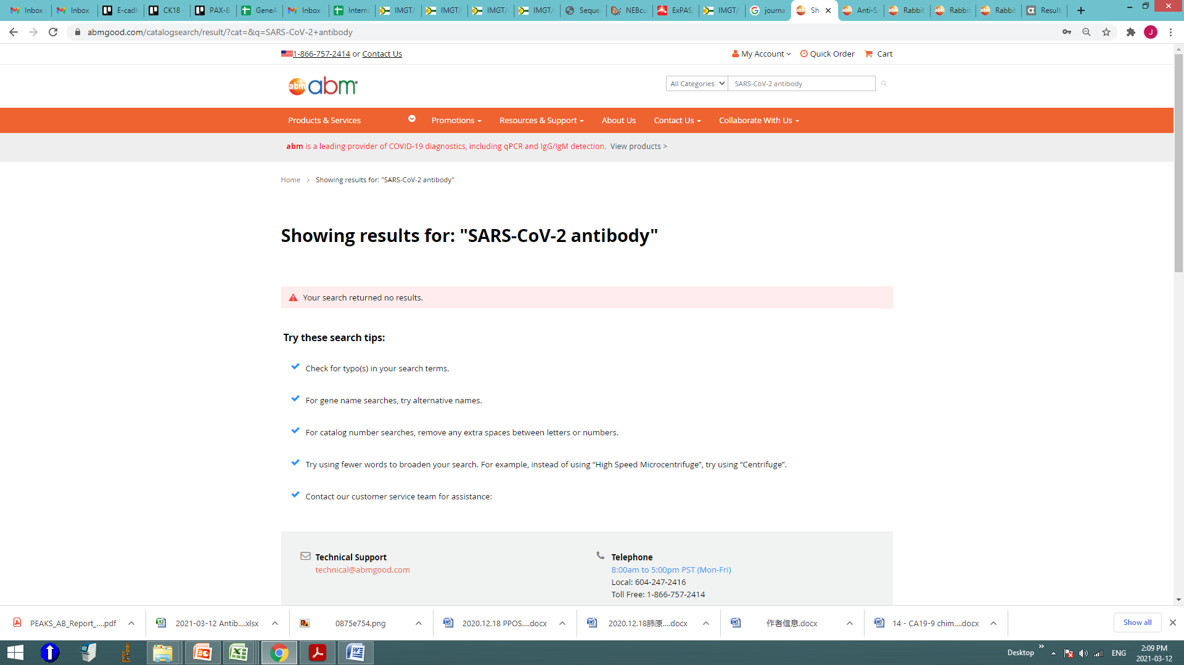

5. Also for some products our product name is not very accurate. For example for SARS2-S protein antibody, we have “Rabbit Anti-SARS-CoV-2 Spike Glycoprotein Antibody-cat Y300504”, but the description says it is raised in mouse with IgG2b…, then it is not Rabbit.

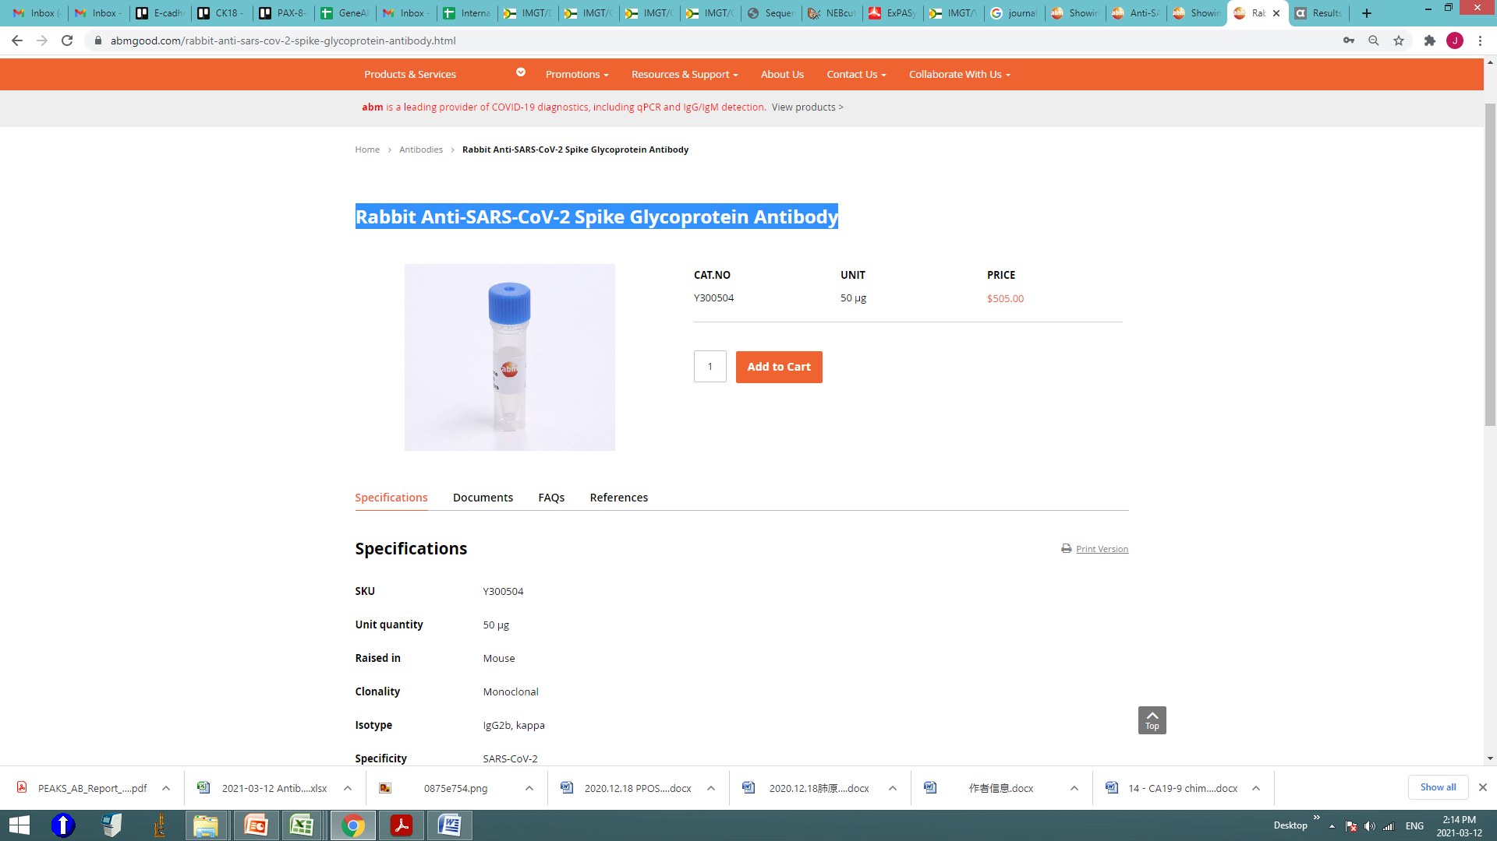

Also, for product G632-9, it is actually partial of N gene not S gene

6. For the antibodies page:

There is too much introduction text on the top area and can not really see the products. The introduction can be less.

We could list our primary antibody/secondary antibody tabs higher so the customer can see them easier.

In the primary antibody page, there are 3 “human” in species reactivity, in antibody application there is (1) but without info, this part is little confusing. Recommend to follow abcam’s filter selections with the followings: Product type, Applications, reactivity, host species, conjugate, modifications, clonality, recombinant, Tag, Isotype. And different filter down list can be folded up to be more convenient. This will make the selection easier for our customer.

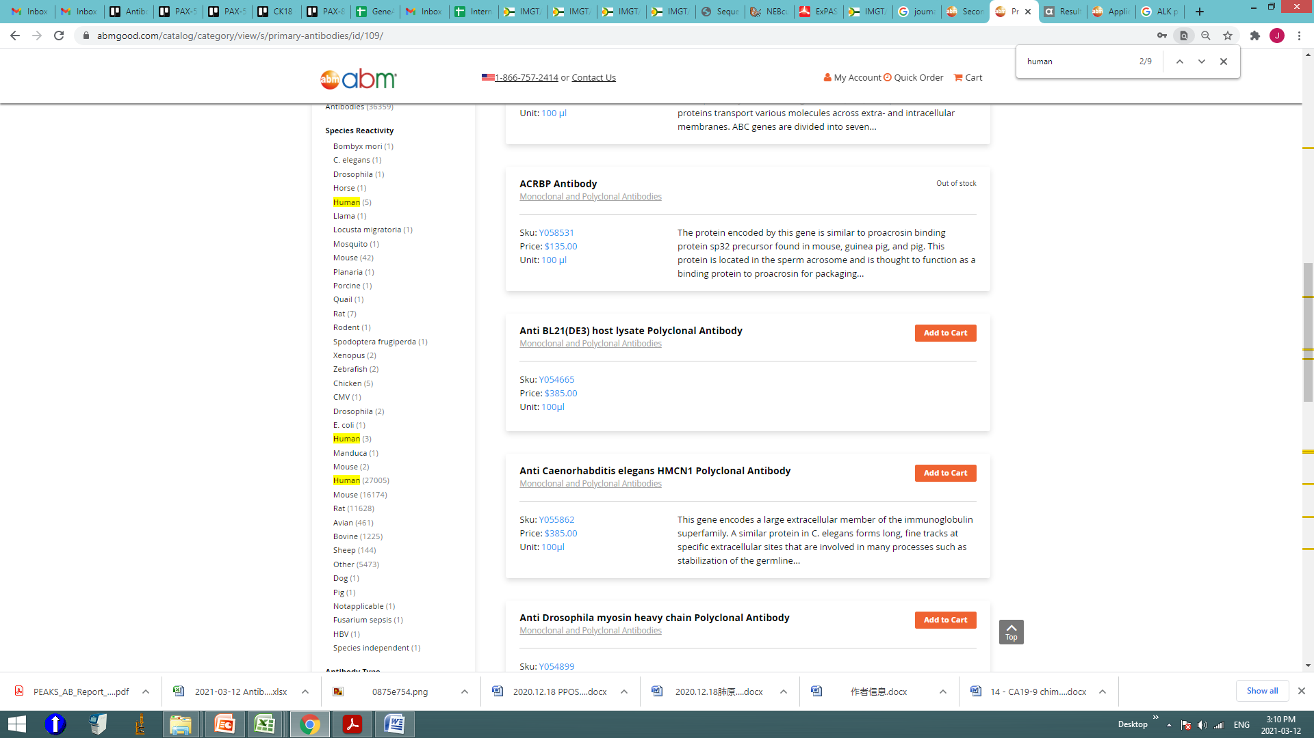

And our product list part can provide more information, including the clonality/clone name, application, conjugate, reactivity, but the description part can be much shorter. A good template can be from abcam as below:

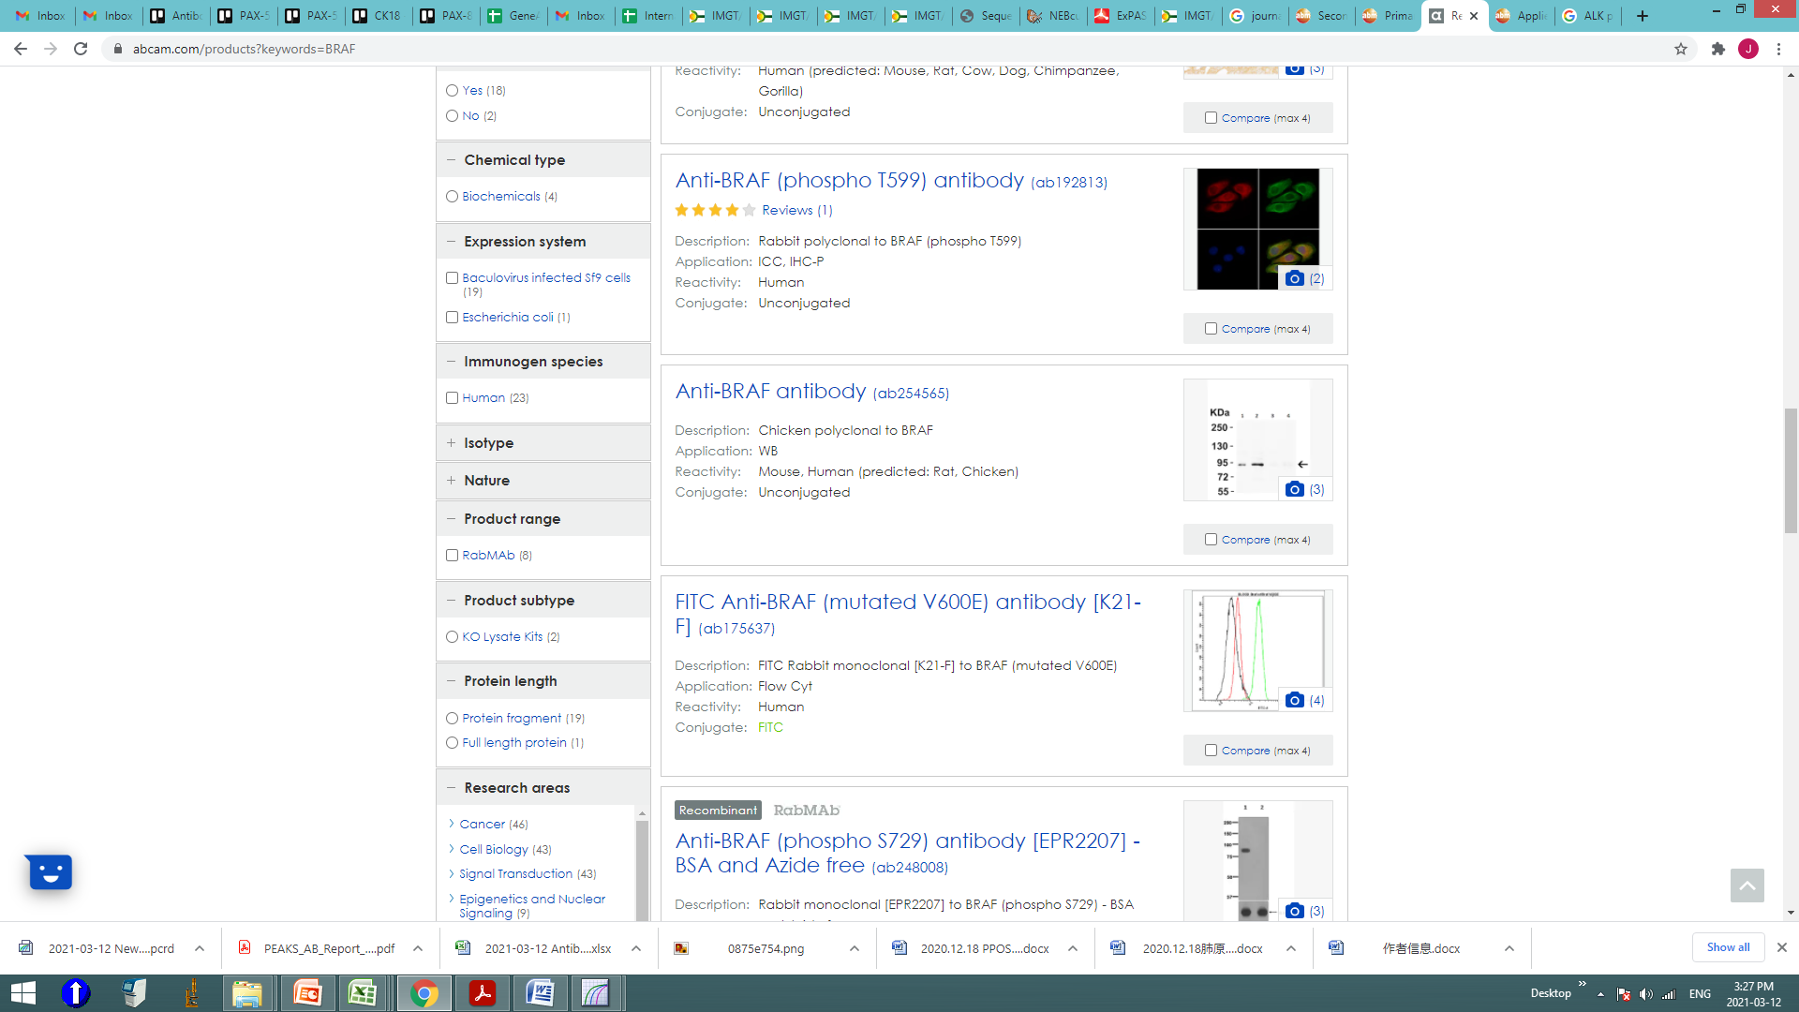

7. Many of our antibodies’ names I guess were automatically generated, so it is like “[Anti-Goat anti TSH -HRP Antibody](https://www.abmgood.com/anti-goat-anti-tsh-hrp-antibody-y107222.html)” they are not right with 2 anti there

